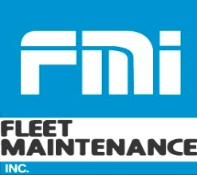

EMPLOYEE BENEFITS 2021

- Life Insurance: $15,000.00-company paid.

- 401K Retirement Plan: After one year of service you are entitled to enroll into the 401K plan. You can defer any amount up to 100% of your pay. The company matches $0.25 for every $1.00 the employee contributes, up to 8%.

- Profit Sharing Plan: The Company contributes sharing at fiscal year-end depending on amount of profits.

- Uniforms: The Company provides uniforms at no charge.

- Health Insurance: The Company offers coverage with Blue Cross and Blue Shield. Plan is administered through NFADA. The company pays for the health insurance along with a weekly employee contribution depending on the plan chosen.

- Holidays: The company provides 6 paid holidays after 90 days of service to include New Years Day, Memorial Day, Independence Day, Labor Day, Thanksgiving Day and Christmas Day.

- NYS Personal/Sick Time: Employee accrues one hour per 30 hours worked up to five paid sick days per year.

- Vacation Policy:
  - After one complete year of service an employee is entitled to one-week paid vacation.
  - After three years of service an employee is entitled to two weeks paid vacation.
  - After ten years of service an employee is entitled to three weeks paid vacation.

- Training: The company provides paid training including all expenses, tuition, and salary. The company pays all ASE testing fees upon passing and pays NYS inspector license fees. Company trains & provides a vehicle for CDL.

- Company Events: There are various company/employee functions throughout the year such as, 4th of July BBQ, open house events, and Christmas lunch.

- Payroll: Employees are paid weekly on Thursday, with an option for direct deposit.
01/01/10

